**SAP Data Intelligence - Snowflake**

**Connectivity Standards and Guidelines**

< Version 1.0 >

**Project Goldilocks – AN**

**DOCUMENT CONTROL:**

**Document Revision History**

|  |  |  |  |
| --- | --- | --- | --- |
| **Revision Number** | **Revision Date** | **Summary of Changes** | **Revised By** |
| 1.0 | 26-06-2022 | Initial Draft | Ankit Sharma |
|  |  |  |  |
|  |  |  |  |
|  |  |  |  |
|  |  |  |  |

**Approvals**

This document requires the following approvals:

|  |  |  |
| --- | --- | --- |
| **Name** | **Title** | **Date** |
|  |  |  |
|  |  |  |
|  |  |  |
|  |  |  |

SAP DI -Snowflake Integration steps performed

**Creation of User id and role:**

To setup a connectivity from SAP DI to Snowflake, specific user id and role needs to be created in Snowflake.

**Steps:**

1. Create a Jira story with Project details and purpose of requesting to create a new user id and role.
2. Assign the task to Snowflake Admin team.
3. Jira story sample format: <https://kraftheinz.atlassian.net/browse/KAPSNF-780>
4. Mentioned below details in Jira story with Architecture Diagram.

|  |  |  |  |  |
| --- | --- | --- | --- | --- |
| Role Name | ENV | Snowflake External User name - Service Account | Subnet IP range | owner mail id of this user (should be KHC person) |
| dev_khc_sapdi | Dev | khc_sapdi_conn_user_dev | 10.248.18.0/24 | [Rajendra.Aravapalli@kraftheinz.com](mailto:Rajendra.Aravapalli@kraftheinz.com) |

**Architecture Diagram**

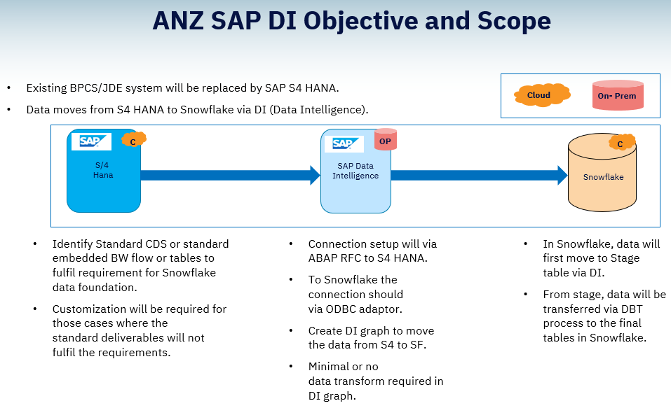

**SAP Data Intelligence outbound IP Address details and Network Policy**

1. Mention below details in Jira story to align security team on network policy:
2. If it’s a POC or ARB Approved Project?
3. Who owns this outbound IP Address?
4. What is the business case for this Request?
5. Architectural Diagram to support this ask?
6. Request SAP DI Basis team to provide the outbound range of IP address to snowflake team to create a network policy on user and allow access from DI IP address.

**Creation of new Database in Snowflake**

1. Create another Jira story to raise a request with Snowflake Admin team to create new Database and schema in order to load the data into Snowflake tables.
2. Provide User id and role of SAP DI for which read,write access needs to be granted in Snowflake database and schema.

Sample Database name- **DBS_GENERIC_NONSECURE_SBX’**

Sample schema name – **INGESTION**

User id - **khc_sapdi_conn_user_dev**

Role - **DEV_KHC_SAPDI**

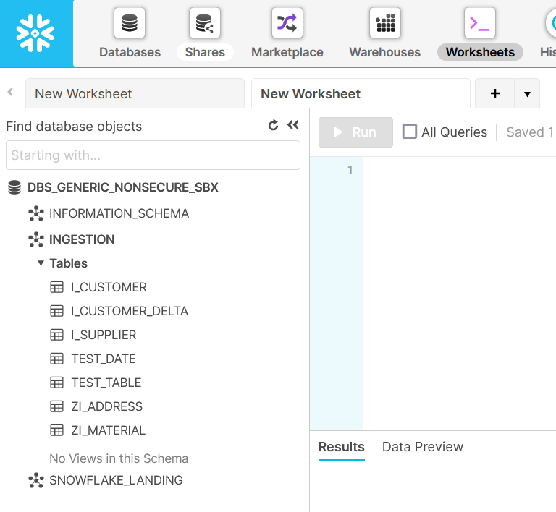

**Connection parameter required**

While creating connection from DI to Snowflake ,Parameters mentioned in below screenshot are required:

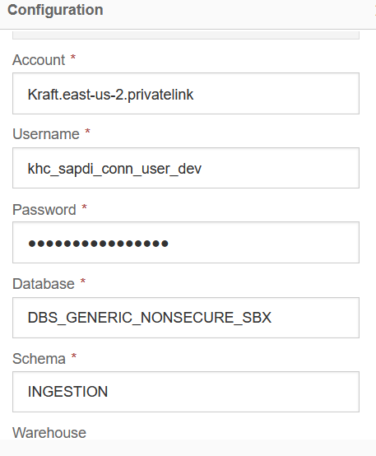

1. Specify the Datawarehouse name (**dev_cloud_analytics_platform**) while connecting with Snowflake from SAP DI.
2. Use account **Kraft.east-us-2. privatelink** to connect with snowflake server.

**Connectivity Test:**

1. Go to the SAP DI Connection Management and select connection type as snowflake.

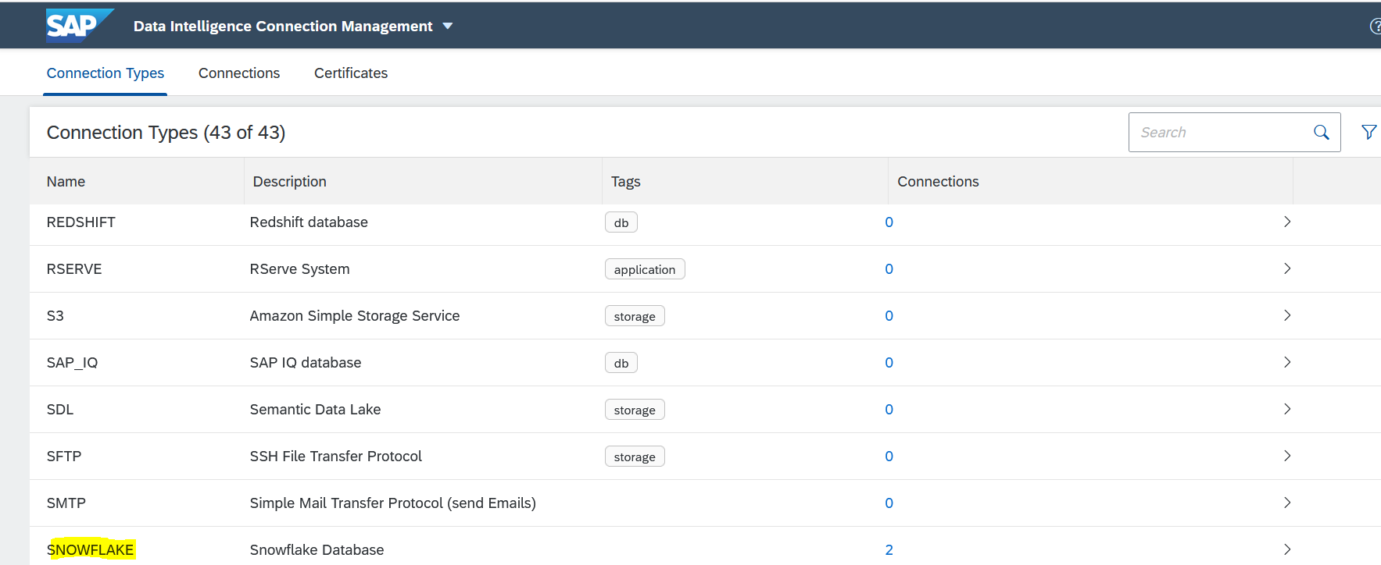

1. Create a new connection with connection type as snowflake and enter the required details:

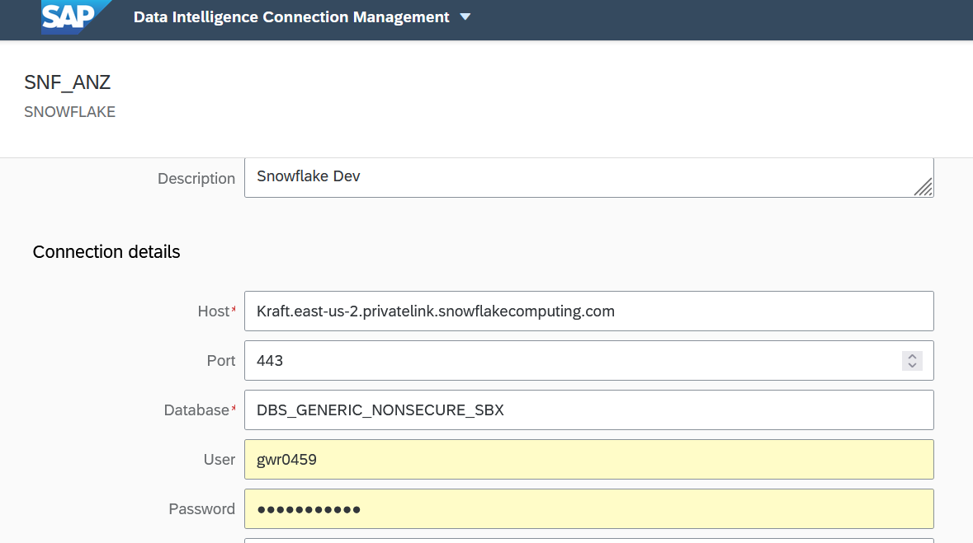

1. Click on Test connection.

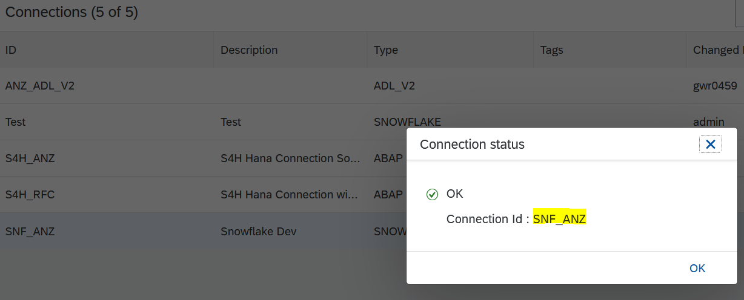

1. Save the connection.